DDL and DML Commands

# DDL:

1.Create

It is used to create the table in a mysql database objects(tables,views,index….)

Syntax:

Create table <tablename>(sno number(10),name varchar(10),marks number(500));

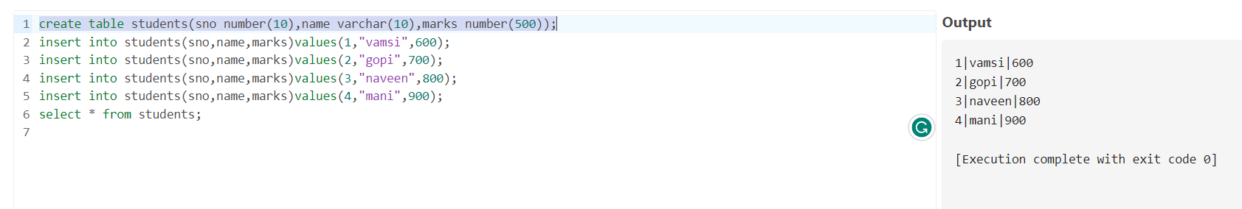

2.ALTER:

It is used to alter the table by adding the columns. In this we have two commands i.add, ii.modify.

Add:

By using add command we can add the column to the table.

Syntax:

Alter table <tablename> add (column type(size));

Ex:

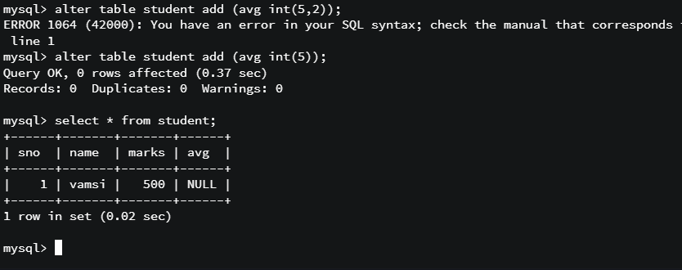

modify:

It is used to modify the existing column size of a table.

Syntax:

Alter table <tablename> modify <column_name> datatype(size);

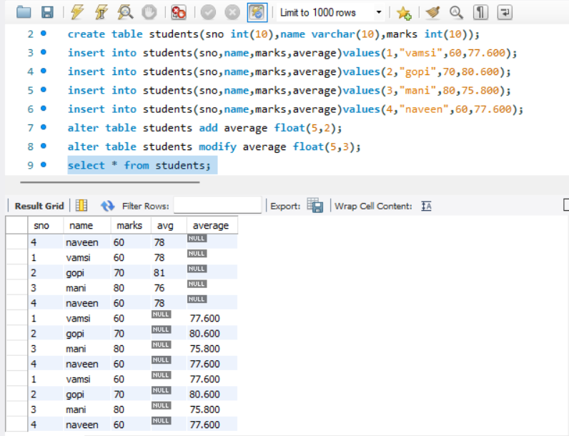

3.RENAME:

It is used to rename the existing with a new name.

Syntax:

Rename table <oldtable_name> to <newtable_name>;

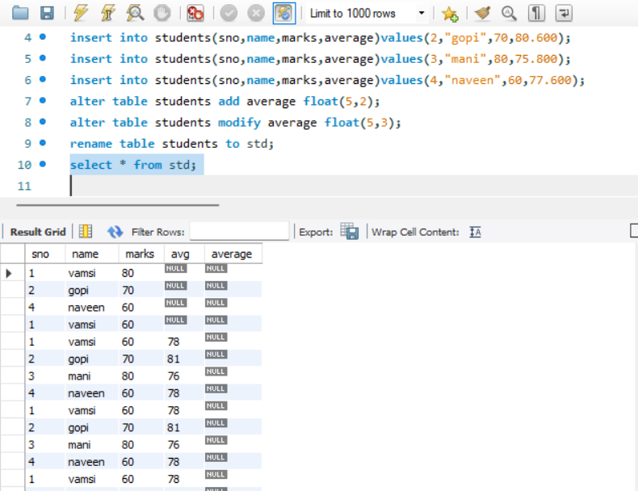

4.TRUNCATE:

It is used to remove the data of a table without affecting the structure of a table.

Syntax:

Truncate table <tablename>;

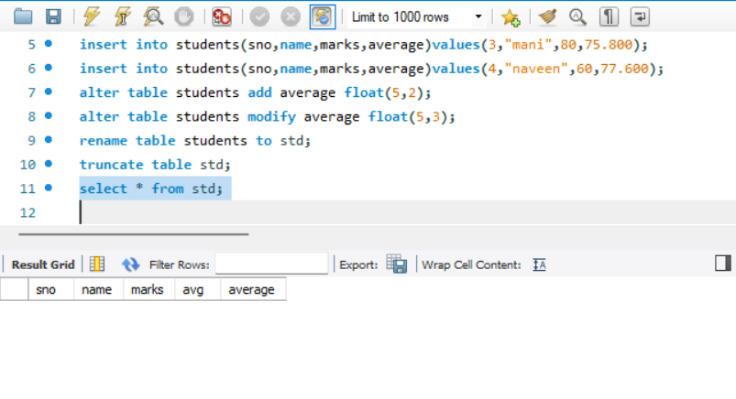

5.DROP:

It is used to delete the entire structure of a table.

Syntax:

Drop table <tablename>;

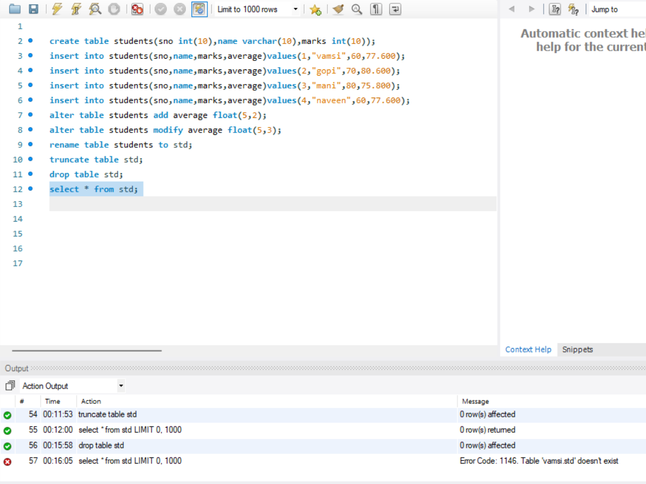

**DML:**

1.insert:

This command is used to insert a values into a table.

Syntax:

Insert into <tablename> values (list of values orderwise);

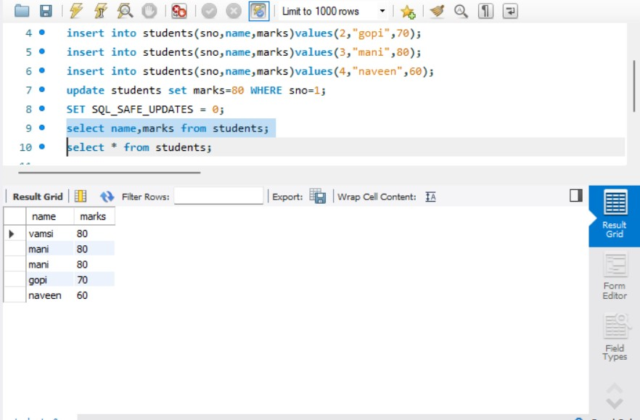

2.SELECT:

This command is used to display records from a table.

Syntax:

Select * from <tablename>;



3.UPDATE:

It is used to update the data of a table.

Syntax:

Update table <tablename> set column=value where <condition>;

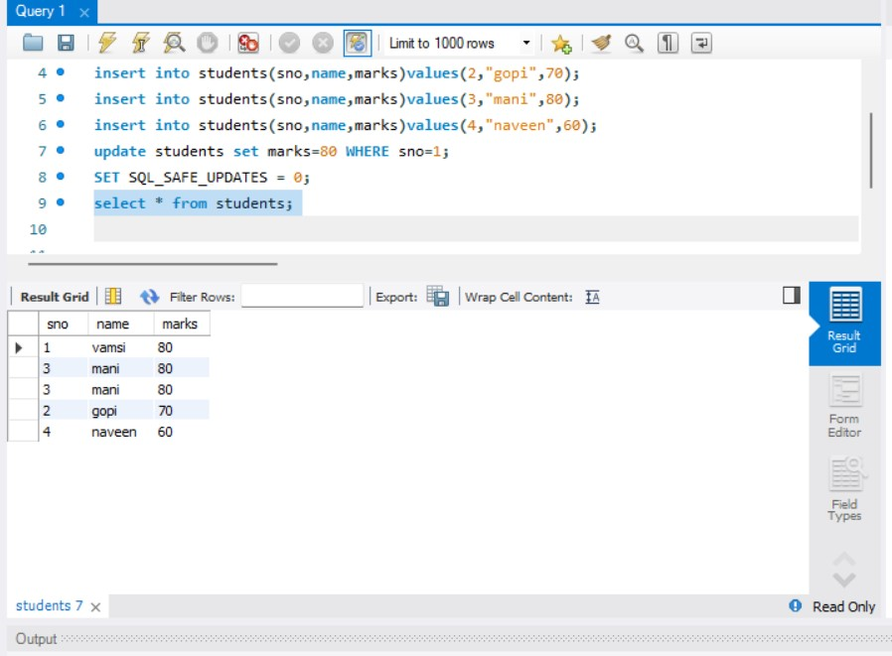

4.DELETE:

This command is used to delete a particular record or a entire record from a table.

Syntax:

Delete from <tablename> where <condition>;

